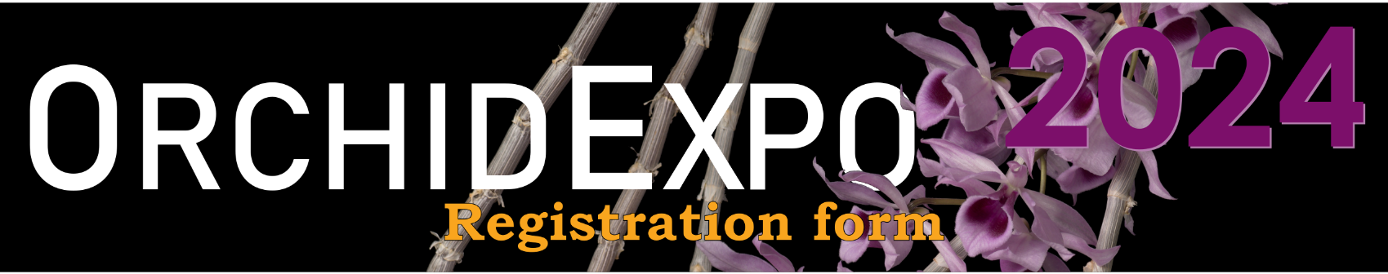
Exhibitor’s name:
Address:
Phone number: |  |  | Email:
Number of ID badges required: _______
Name of all participants on your team (if possible) :

*** For security reasons, any person who helps with assembly, dismantling or sales must at all times wear the identification badge issued by the Orchidophiles of Montreal.***
Type of exhibit: | ☐ Plant exhibit  ☐ Floral arrangement / Ikebana |  |  |  | ☐ Educational exhibit  ☐ Artwork
All orchid vendors must contribute to the success of the exhibition by creating an artistic display that reflects the quality, quantity and diversity of the plants they offer for sale to visitors to the exhibition.
All plant displays will be rated by the organizing committee on a quality scale of 1 to 5, with 1 being Poor and 5 being Exceptional. An orchid vendor display must obtain at least 3 points to ensure it remains on the OrchidExpo invitation list for the following year.
Exhibit: | Space required _______ ft X _______ ft  _______ m X _______ m |  |  | Floor exhibit? ☐ Yes  ☐ No
Number of 6-ft long tables: ________
Sales Area:  Number of 6-ft long tables: _______  Number of 7-ft long tables: ________ |  | Payment before December 31, 2023  240$ each  280$ each |  |  |  | Payment after January 1st, 2024  290$ each  330$ each
Special needs :
Modification or cancellation
If you need to change or cancel your registration, please inform Mario as soon as possible at mariomireault@gmail.com
SEND THE COMPLETED REGISTRATION FORM TO:

