Member  number | MEMBERSHIP FORM
 | In block letters, please
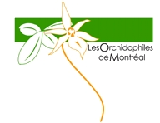 | Year  1. Firstname, Name  2. Firstname, Name  Address  City  Phone # (Home)  E-mail | 2023 - 2024  ...........................................................................................  ...........................................................................................  ...........................................................................................  ........................................ Postal Code ............................  (......) ............................... (Work) (......) ............................  ...........................................................................................  ...........................................................................................
www.orchidophilesmontreal.com
Note : your membership and our activities run from September to the following August | Signature .........................................................................  Send an email and e-transfer to orchidophilesmontreal@gmail.com  or join a check payable to La Société des Orchidophiles de Montréal  and send it with the form to 2173, rue de Bavière, Laval (Québec), H7M 4Y7

